Importing Data - OMERO.insight version 4.4

Using the OMERO.insight to import image data onto the OMERO server.

1 Select Import from the File menu;
or Click on the Import icon in the toolbar;
or Select a destination Project or Dataset for the imported data and right click then select Import.

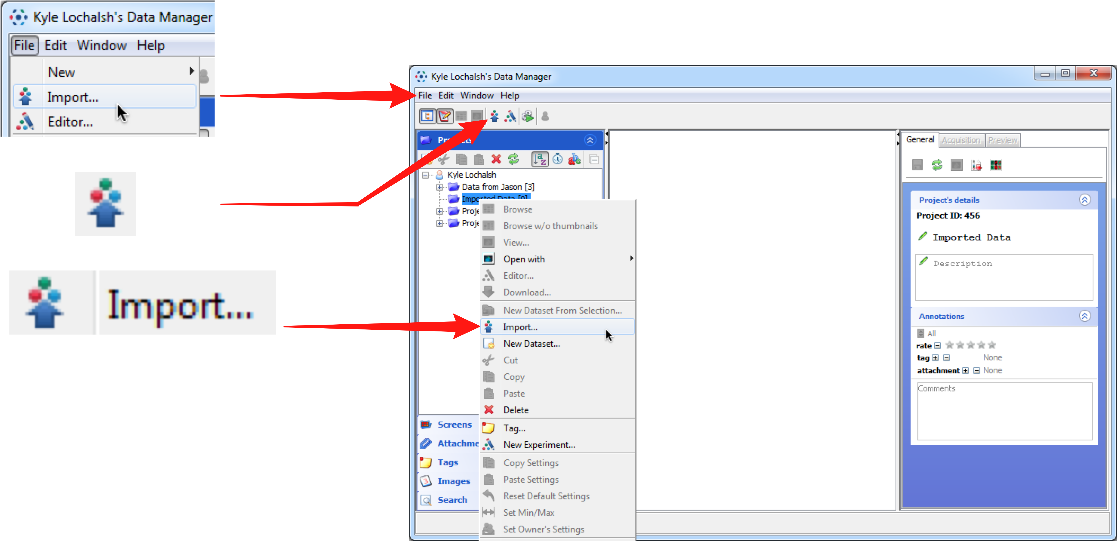

2 Use the File Finder to locate data to be imported on local or networked drives.
Select files for importing and click the top arrow to add them to the import queue.

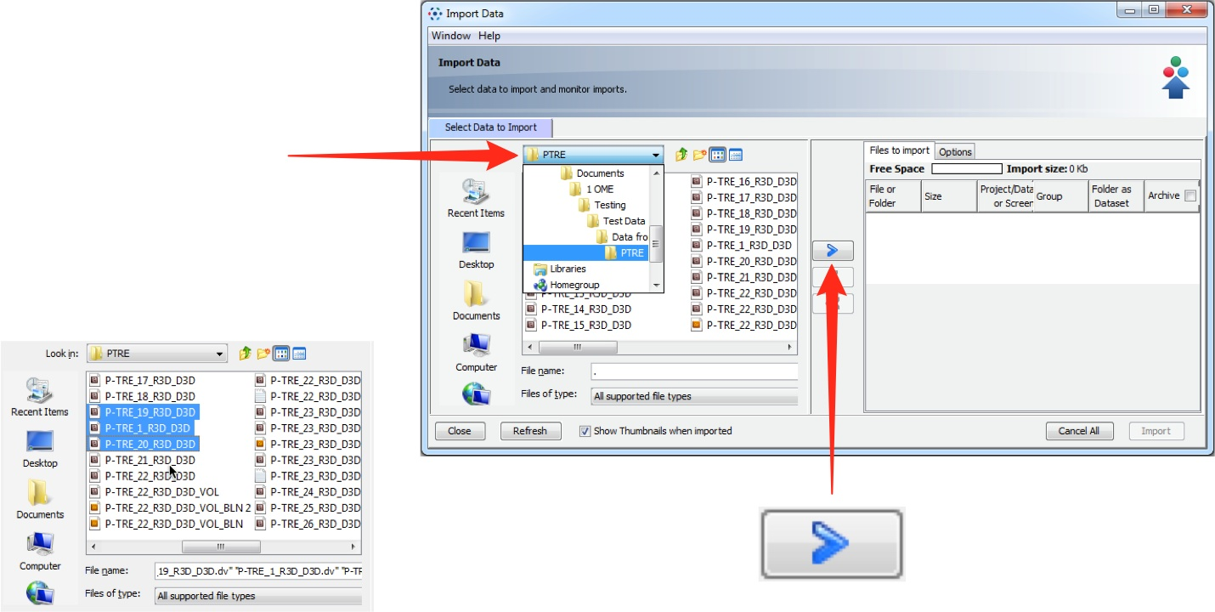

3 Use the Location Selection window to determine to where the data will be imported.
Choose an existing project or dataset using the drop-down menus;
or Click New to create a new project or dataset.
When import location has been set, click Add to the Queue.

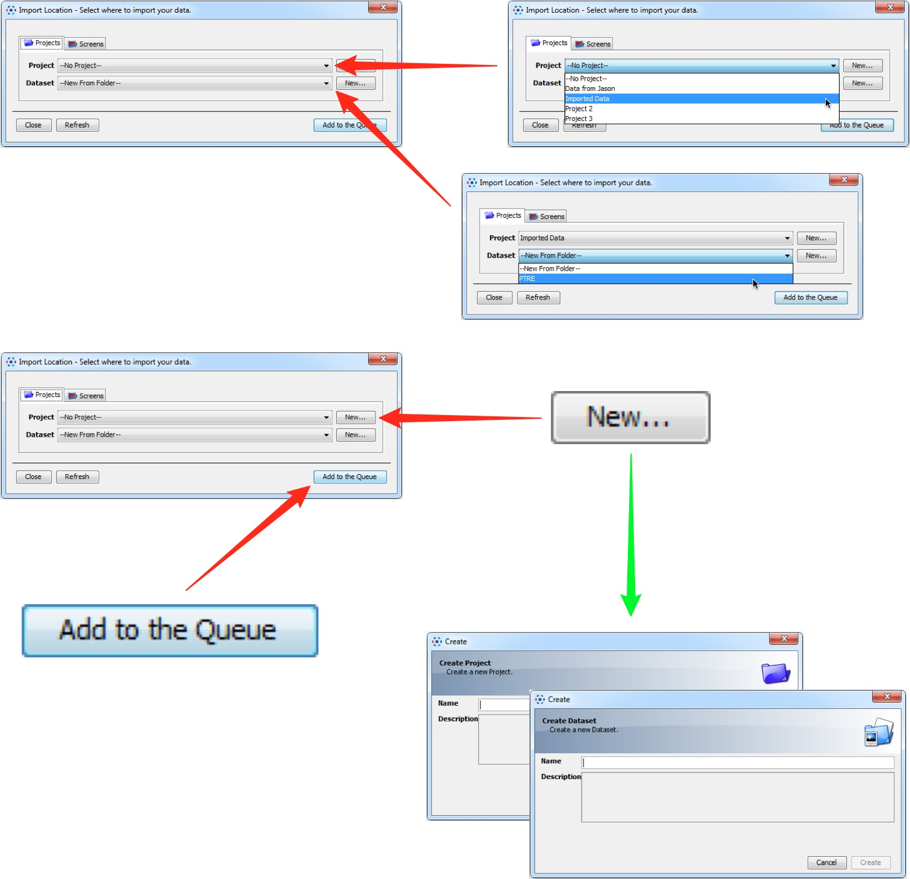

4 When ready, click Import to start importing queued data.
The progress of imports is shown in the Import tab.
A green tick indicates when the queue is successfully imported.

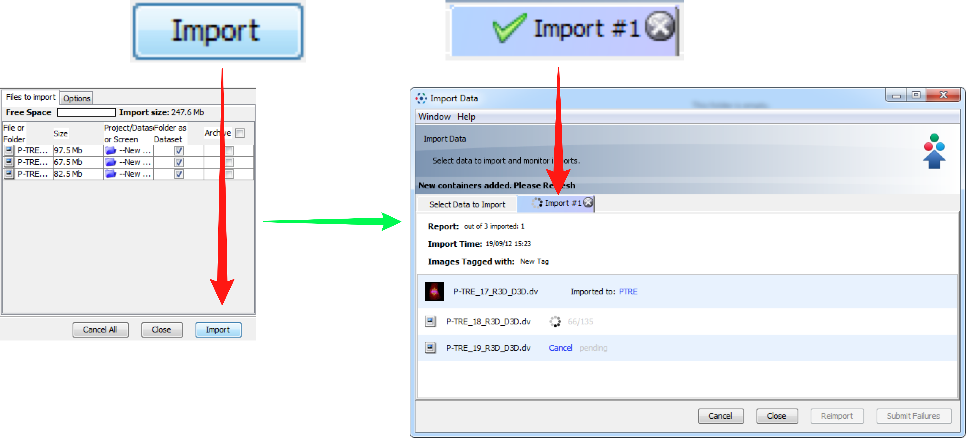

5 Mouse-over the thumbnails of successfully imported images to see a preview.
Click on the link to the dataset or close the Import window to view the data in the Data Manager.

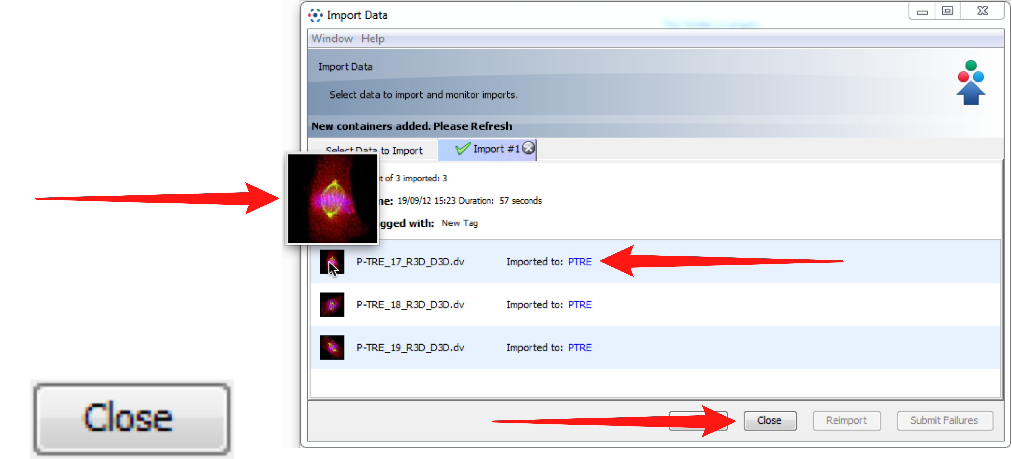

Importing Options

The following points illustrate how to set some of the options that can be used when importing.

Archiving data

To archive data files in their original format on the OMERO server click the Archive checkbox.
Individual data files can be selected or deselected using the checkboxes in the column below.

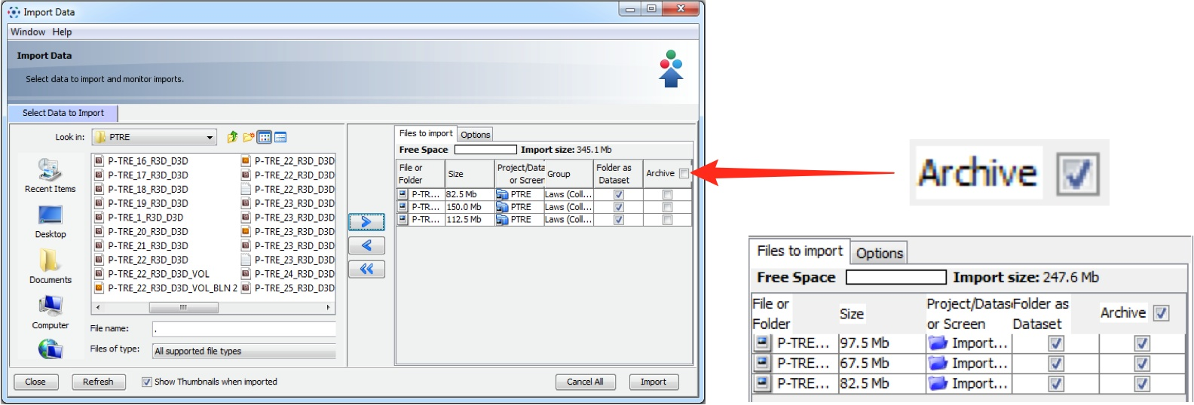

Note
Note: Archiving at import enables subsequent retrieval of the file in the original format at a later date, in addition to the ability to export it as an OME-TIFF.

Adding tags at import

Click the Options tab then Add Tags to batch-add tags to the data as it is imported.

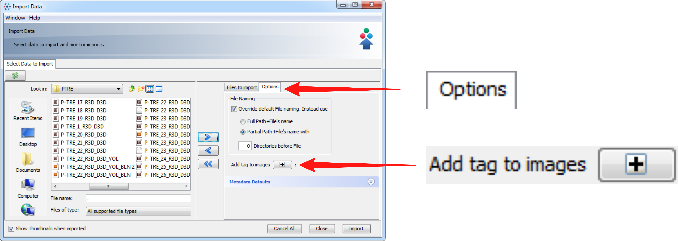

Select an existing tag in the left hand pane and click the right arrow;
or Enter the name of a new tag and click Add.
Click Save to add these tags to the data at import.

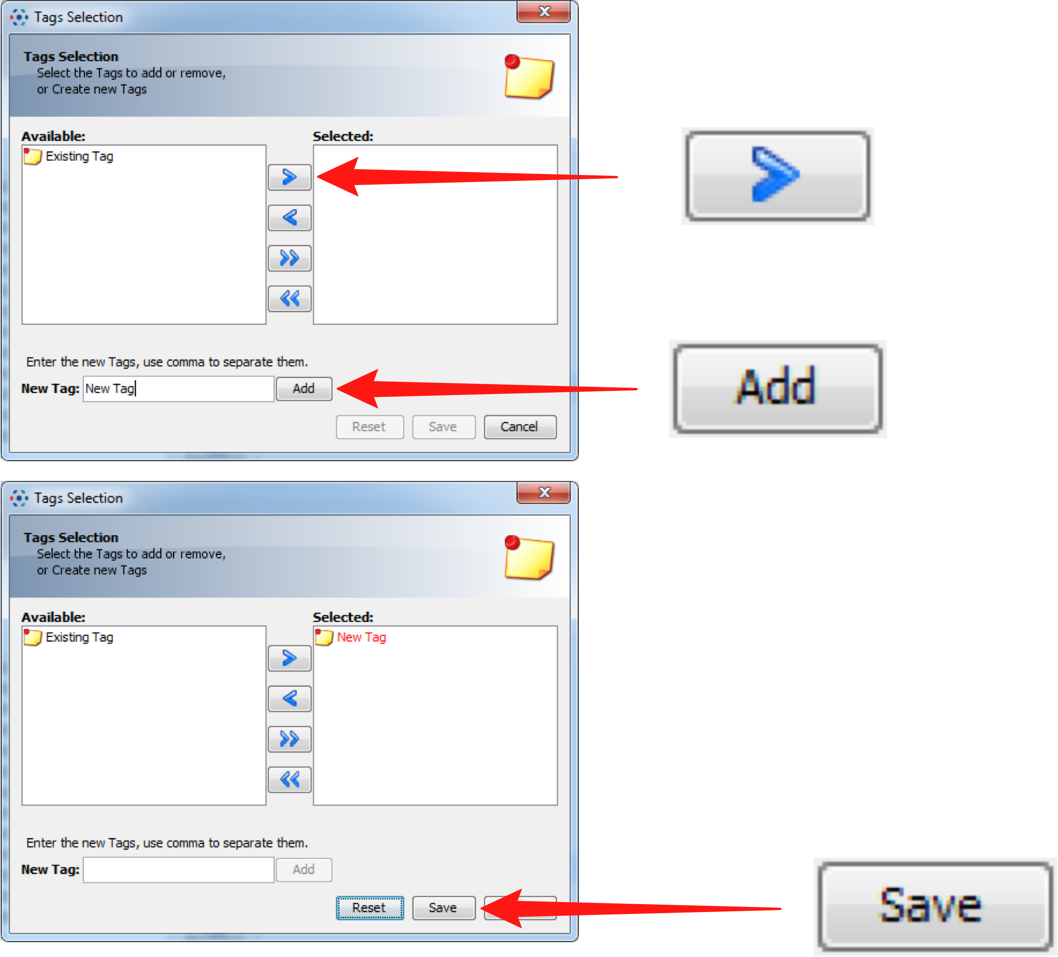

After saving, added tags can be seen in the Options tab and can be removed by clicking the - button

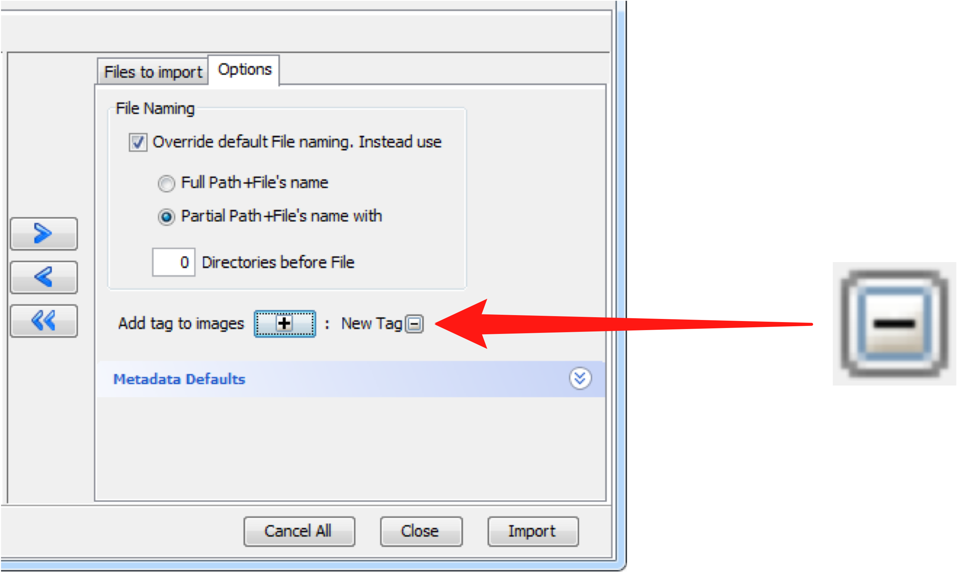

Selecting Group for Import

If you are a member of more than one group, use the Group drop down box to select the group into which to import the data.

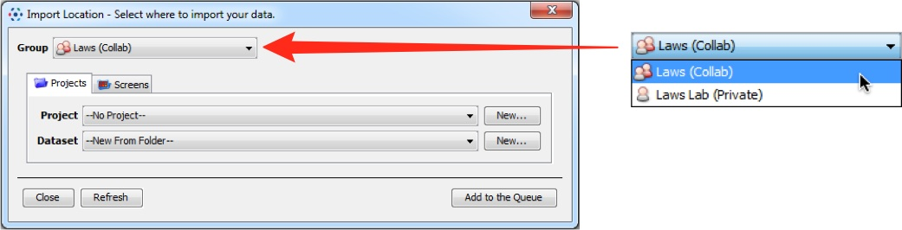

Change between project and screen

Click the Project or Screen tabs to change between image and screen data.
The File Finder window changes to reflect available file types, according to the selection.

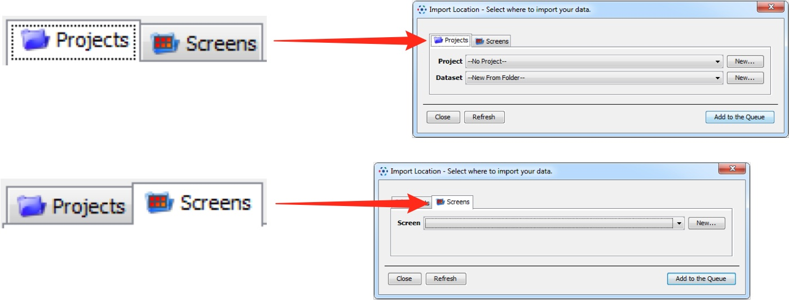

Import for Another User

If you are an Administrator user, use the Import For drop down box to select another user to import the data as.
The chosen user will then own this data.
The projects and datasets shown in the drop-down boxes as available to import into, is determined by the permission status of the group.



