Getting Started with SLS OMERO

Introduction

The School of Life Sciences has an OMERO server called Nightshade that allows you to store image data centrally. You can use the OMERO.insight client to upload, view and download data from any computer or laptop on or off-campus.

Your SLS username and password are used to log into the OMERO server, using the URLs given below. Your OMERO account is automatically created the first time you log in, and if you change your SLS password, OMERO will automatically reflect this.

Installing OMERO.insight

For Windows machines, or Apple Macs where the user has administrative privileges, follow the instructions for downloading and installing in steps 1 and 2 below.

For Apple Mac machines with the standard SLS disc image, where users do not have administrative privileges, use the Self Service app to download OMERO as described in step 3.

1 Download the OMERO.insight client

http://downloads.openmicroscopy.org/latest/omero5

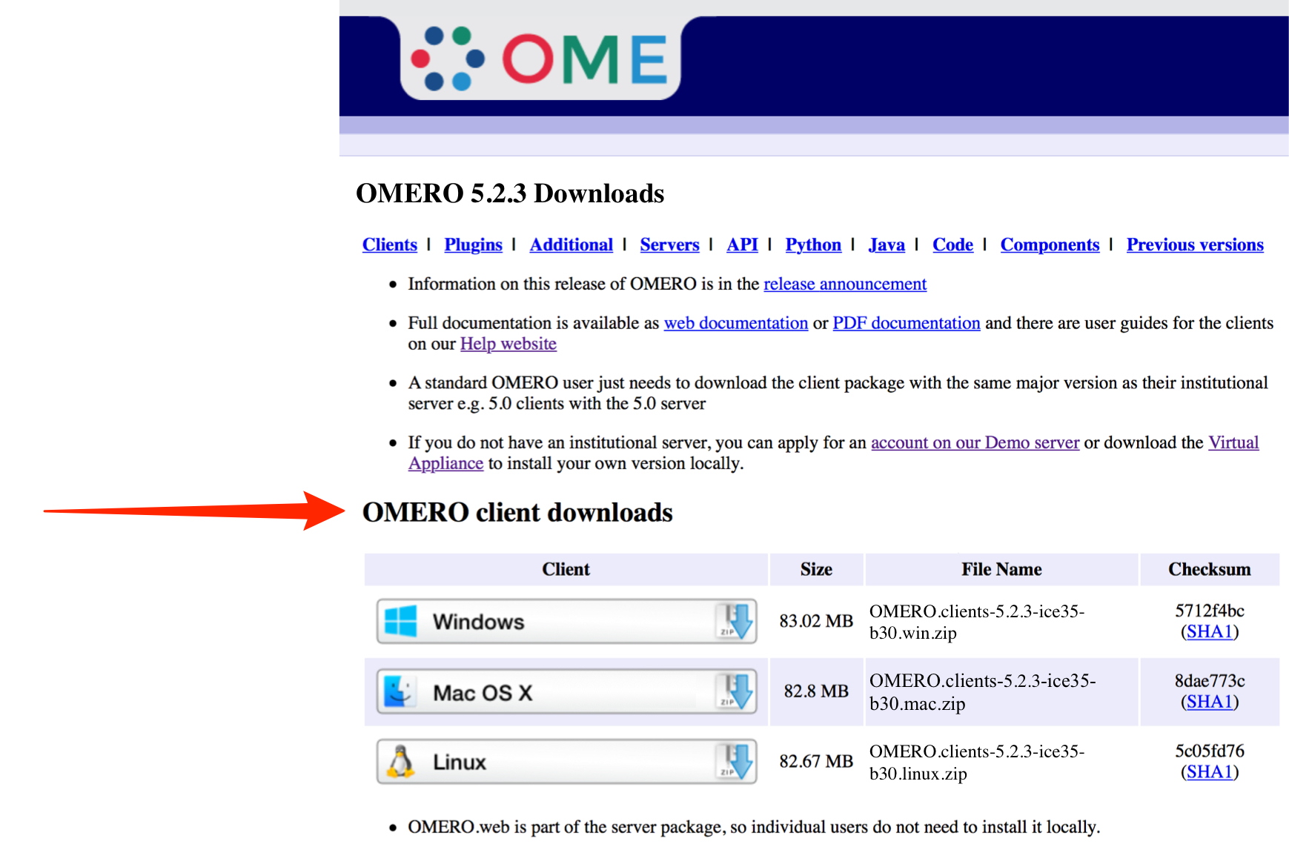

2 Expand the OMERO.insight client archive and move it to your home directory.

Windows:

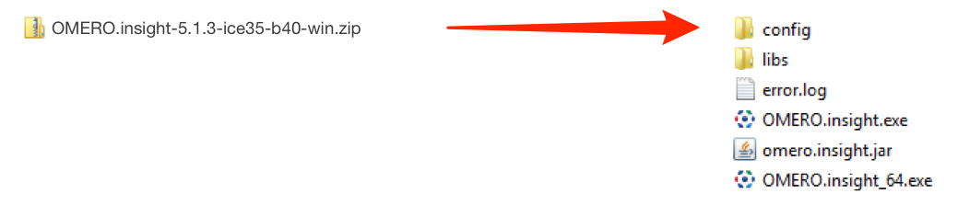

Mac OS X:

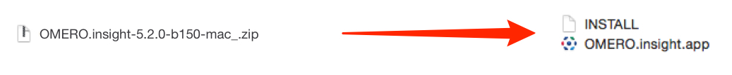

Linux:

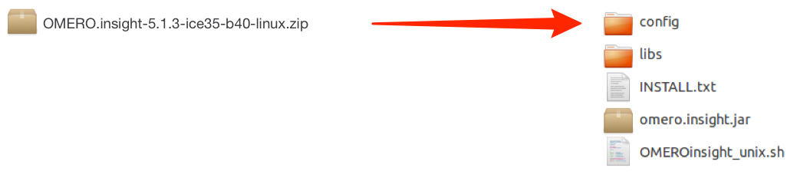
Note: As OMERO.insight is a stand-alone Java application, and does not require installation as such, so you do not need administrator privileges to install it.

On Windows, expand the .zip archive and move the OMERO.clients folder to your Documents or home directory, or the Programs folder if you have the permissions.

On a Mac move the OMERO.clients folder to your Applications folder.

Mac users on machines where they are an administrator may be blocked by a warning that OMERO.insight has been prevented from opening as it is from an unidentified developer.

Follow these instructions to adjust the security settings so OMERO.insight can run on your Mac:

https://support.apple.com/kb/PH14369

3 For Mac users with standard SLS disc images installed (no administrative privileges).
Open the Self Service.app in the Applications folder.
Select the Scientific section from the menu on the right.
Click the Install button for OMERO.

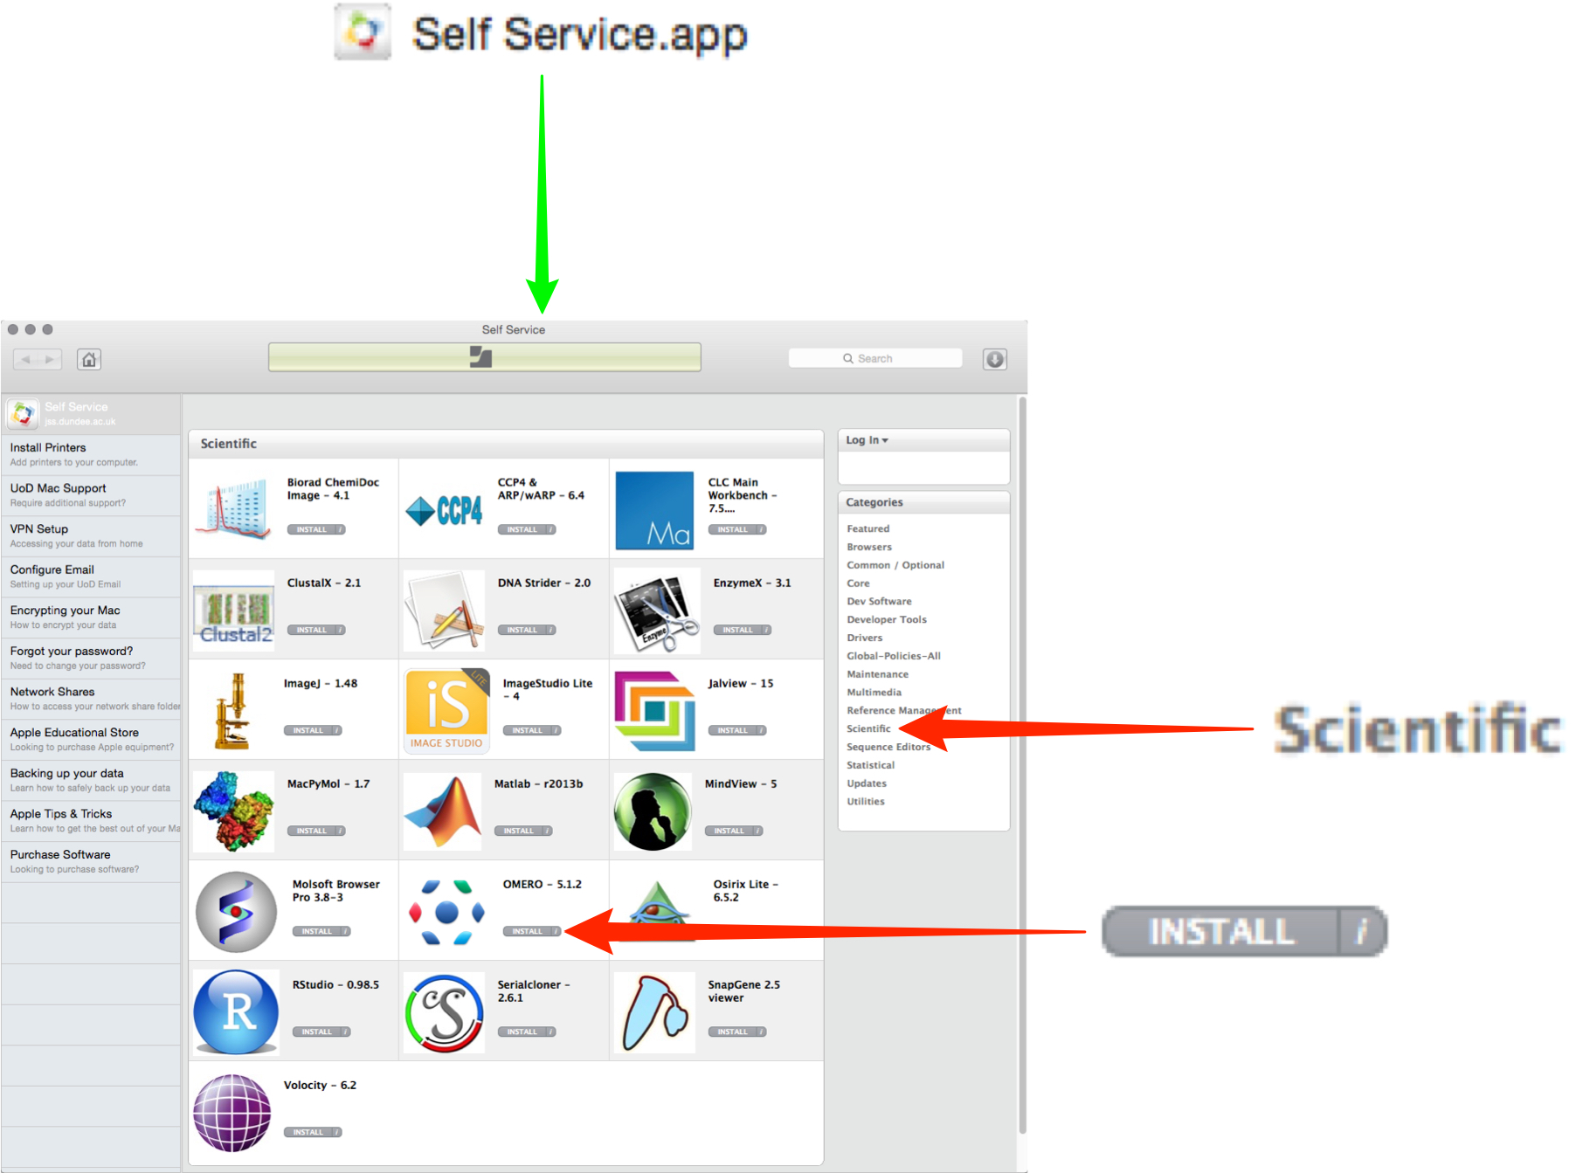

4 Open the OMERO.insight client.

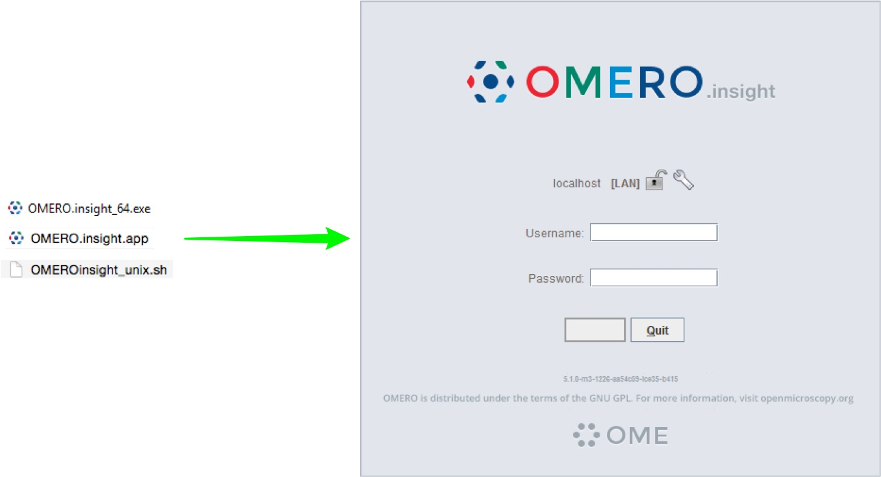

Adding server name and logging in

Adding the server is only required the first time an OMERO server is accessed from the computer.

1 Click on the Spanner icon.

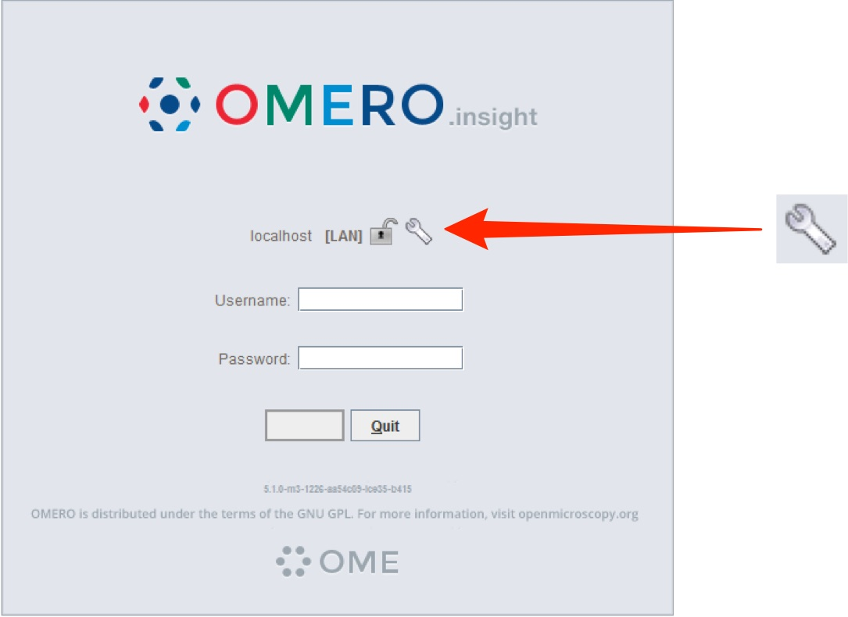

2 In the Add Server dialog box, click on the + icon.
Enter the server address:
nightshade.openmicroscopy.org
Click on Apply.

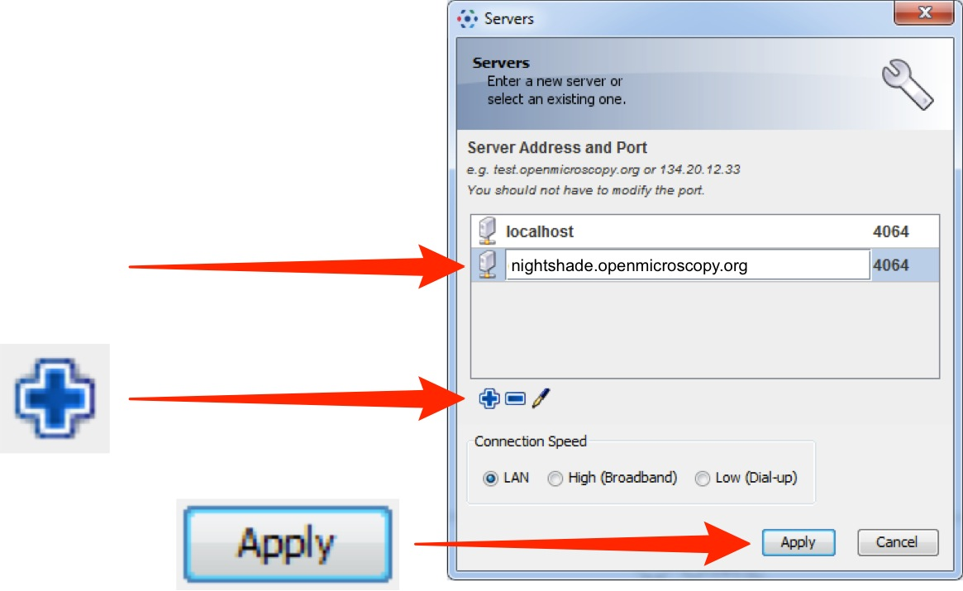

3 Enter your SLS Username and Password.
Click on Login.

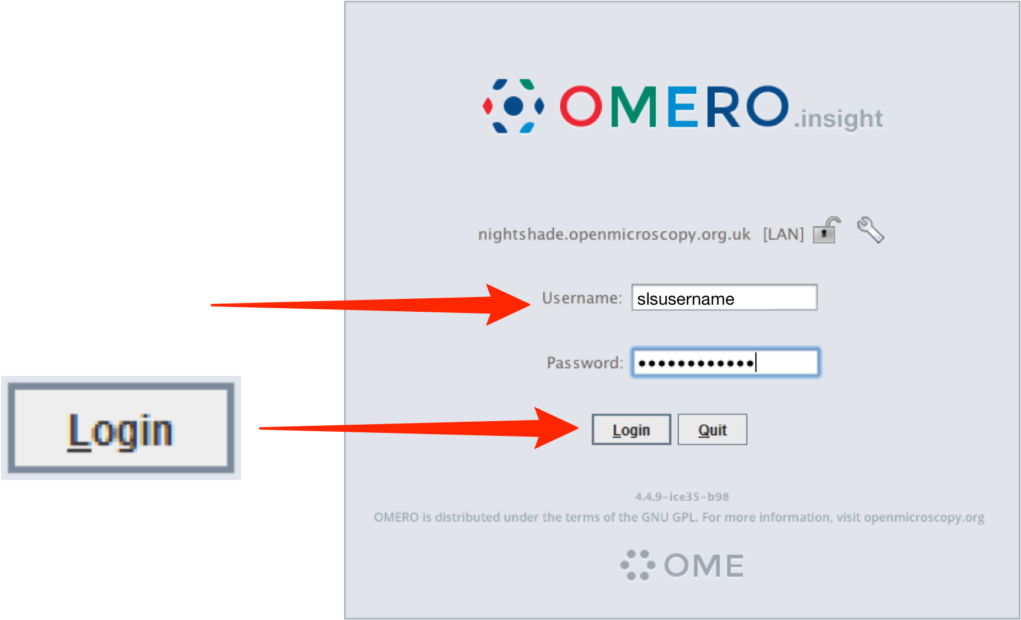

Joining Groups

When you log into OMERO for the first time, you will be in a "default" group, My Data, which is Private, so only you can see data you place in that group. Being a member of a read-only or read-annotate group in OMERO allows you to share data with other members of the group.

Your lab or PI may have a group you wish to use for collaborating with colleagues. Ask your PI to add you to their group or send an email, giving the names of the groups to which you wish to be added, to the Nightshade Administrator at:

nightshade-support@lists.openmicroscopy.org.uk

More details on using groups and sharing data is on the Help page at:

http://help.openmicroscopy.org/sharing-data.html

Importing image data

1 Click on the Importer icon.

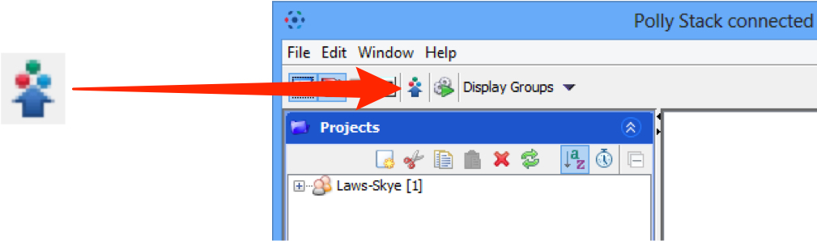

2 Specify a location for saving imported data:
- select a group if you are a member of more than one
- a new project and/or dataset can be created
- an existing project and/or dataset can be selected from the drop-downs
- a new dataset can be automatically created from the source folder
- click Add to the Queue.

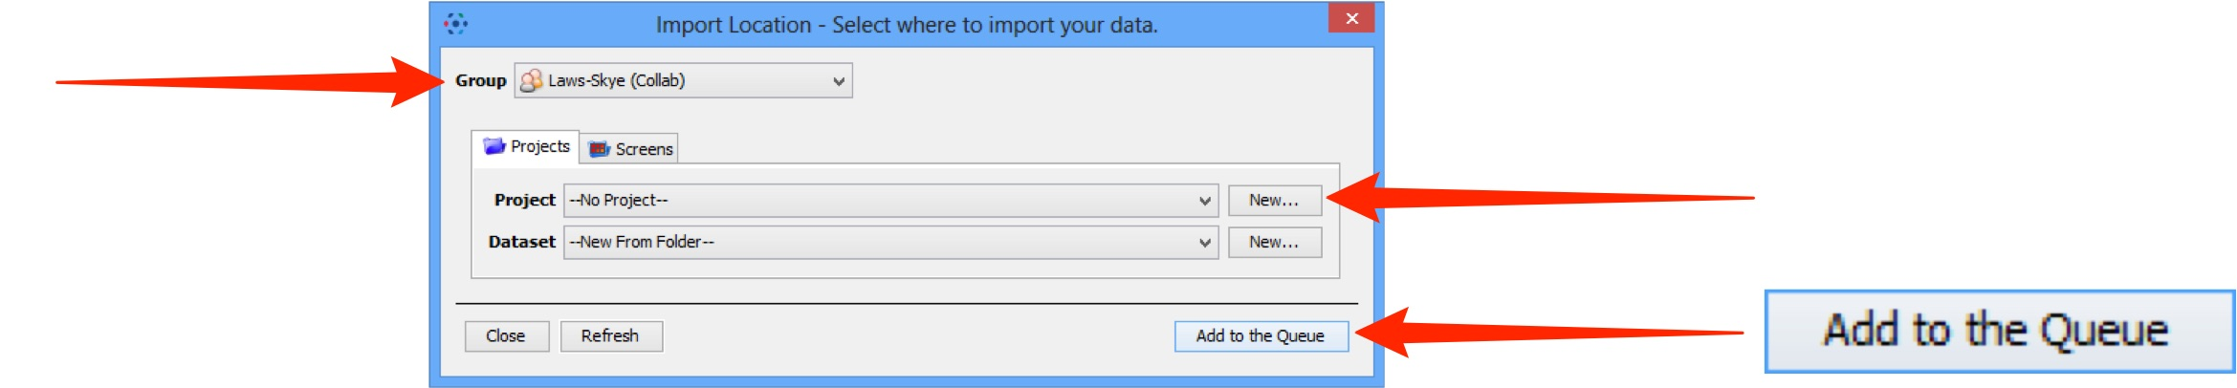

3 Data to be imported appears in the queue pane.
When ready click on Import.

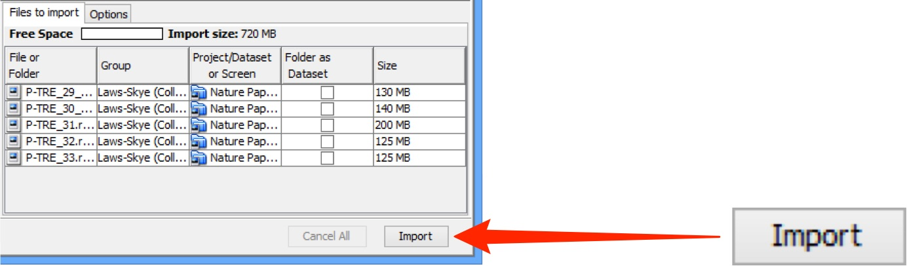

Using OMERO.web

1 OMERO.web allows you to view your data from any web browser with the URL:

nightshade.openmicroscopy.org

You do not have to enter a server name.
OMERO.web uses the same login, and has the same functionality, as OMERO.insight, except OMERO.web cannot import data or create new Regions of Interest (ROIs).

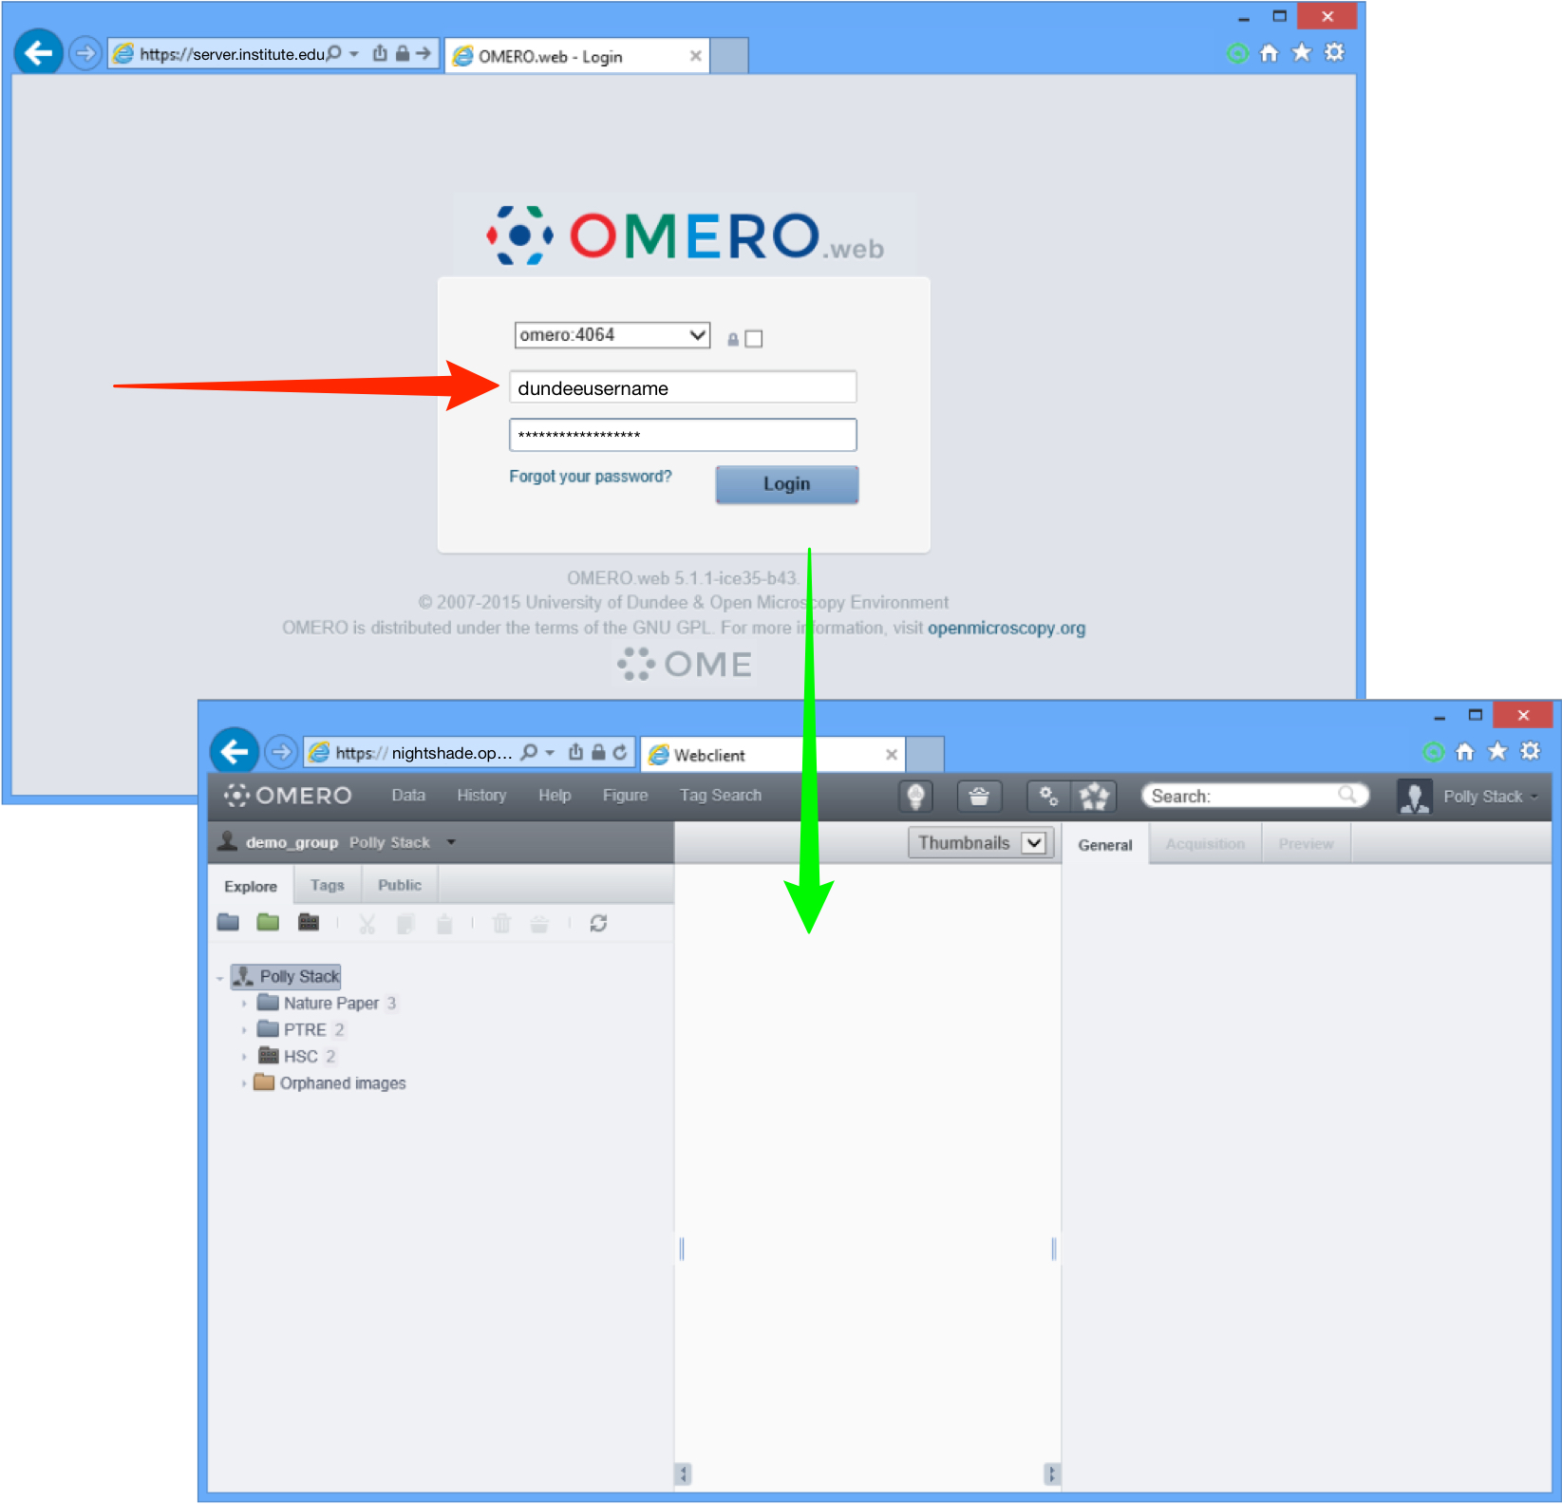

Help and support

Detailed User Guides for common workflows using OMERO.insight and OMERO.web are available online and for download at:

help.openmicroscopy.org

For help to get started using OMERO or any other questions please email us at:

nightshade-support@lists.openmicroscopy.org.uk

