Exporting Images

In OMERO you are able to download any image in its original format, or export it as an OME-TIFF, JPEG, PNG or TIFF image.

The following matrix details the levels at which the different export formats are enabled.

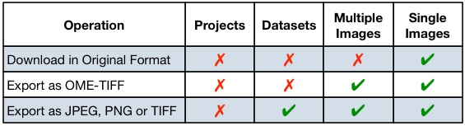

Note: If an image was imported before OMERO version 5.0 it can only be downloaded in the original format if it was archived at import.

1 Click on the Export icon in the toolbar.

OMERO.insight

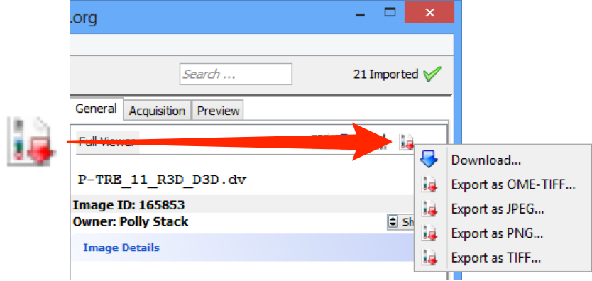

OMERO.web

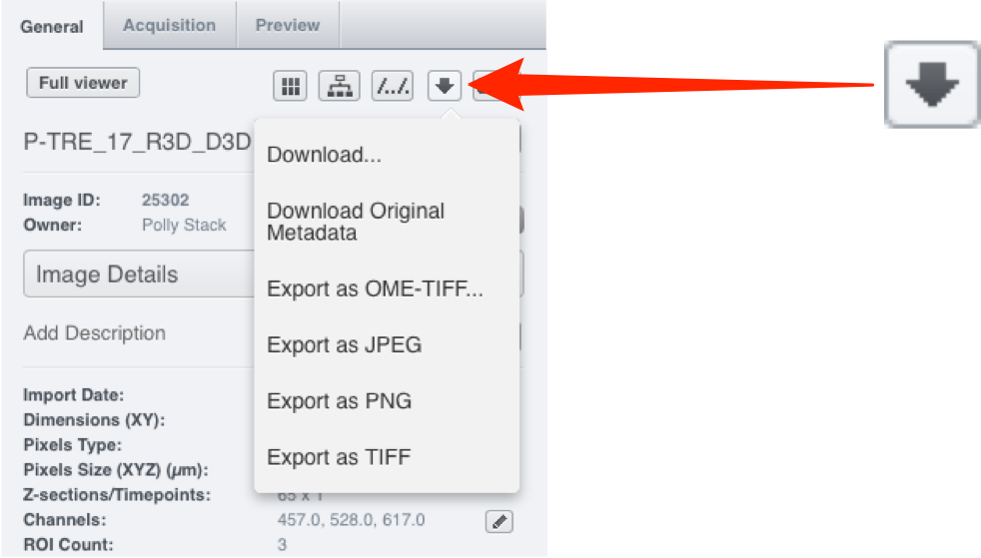

2 Select Download from the drop-down to download the image in its original format.

In OMERO.insight, choose the destination folder in the Download window and click Download.
In OMERO.web the file will be downloaded according to your browser convention.

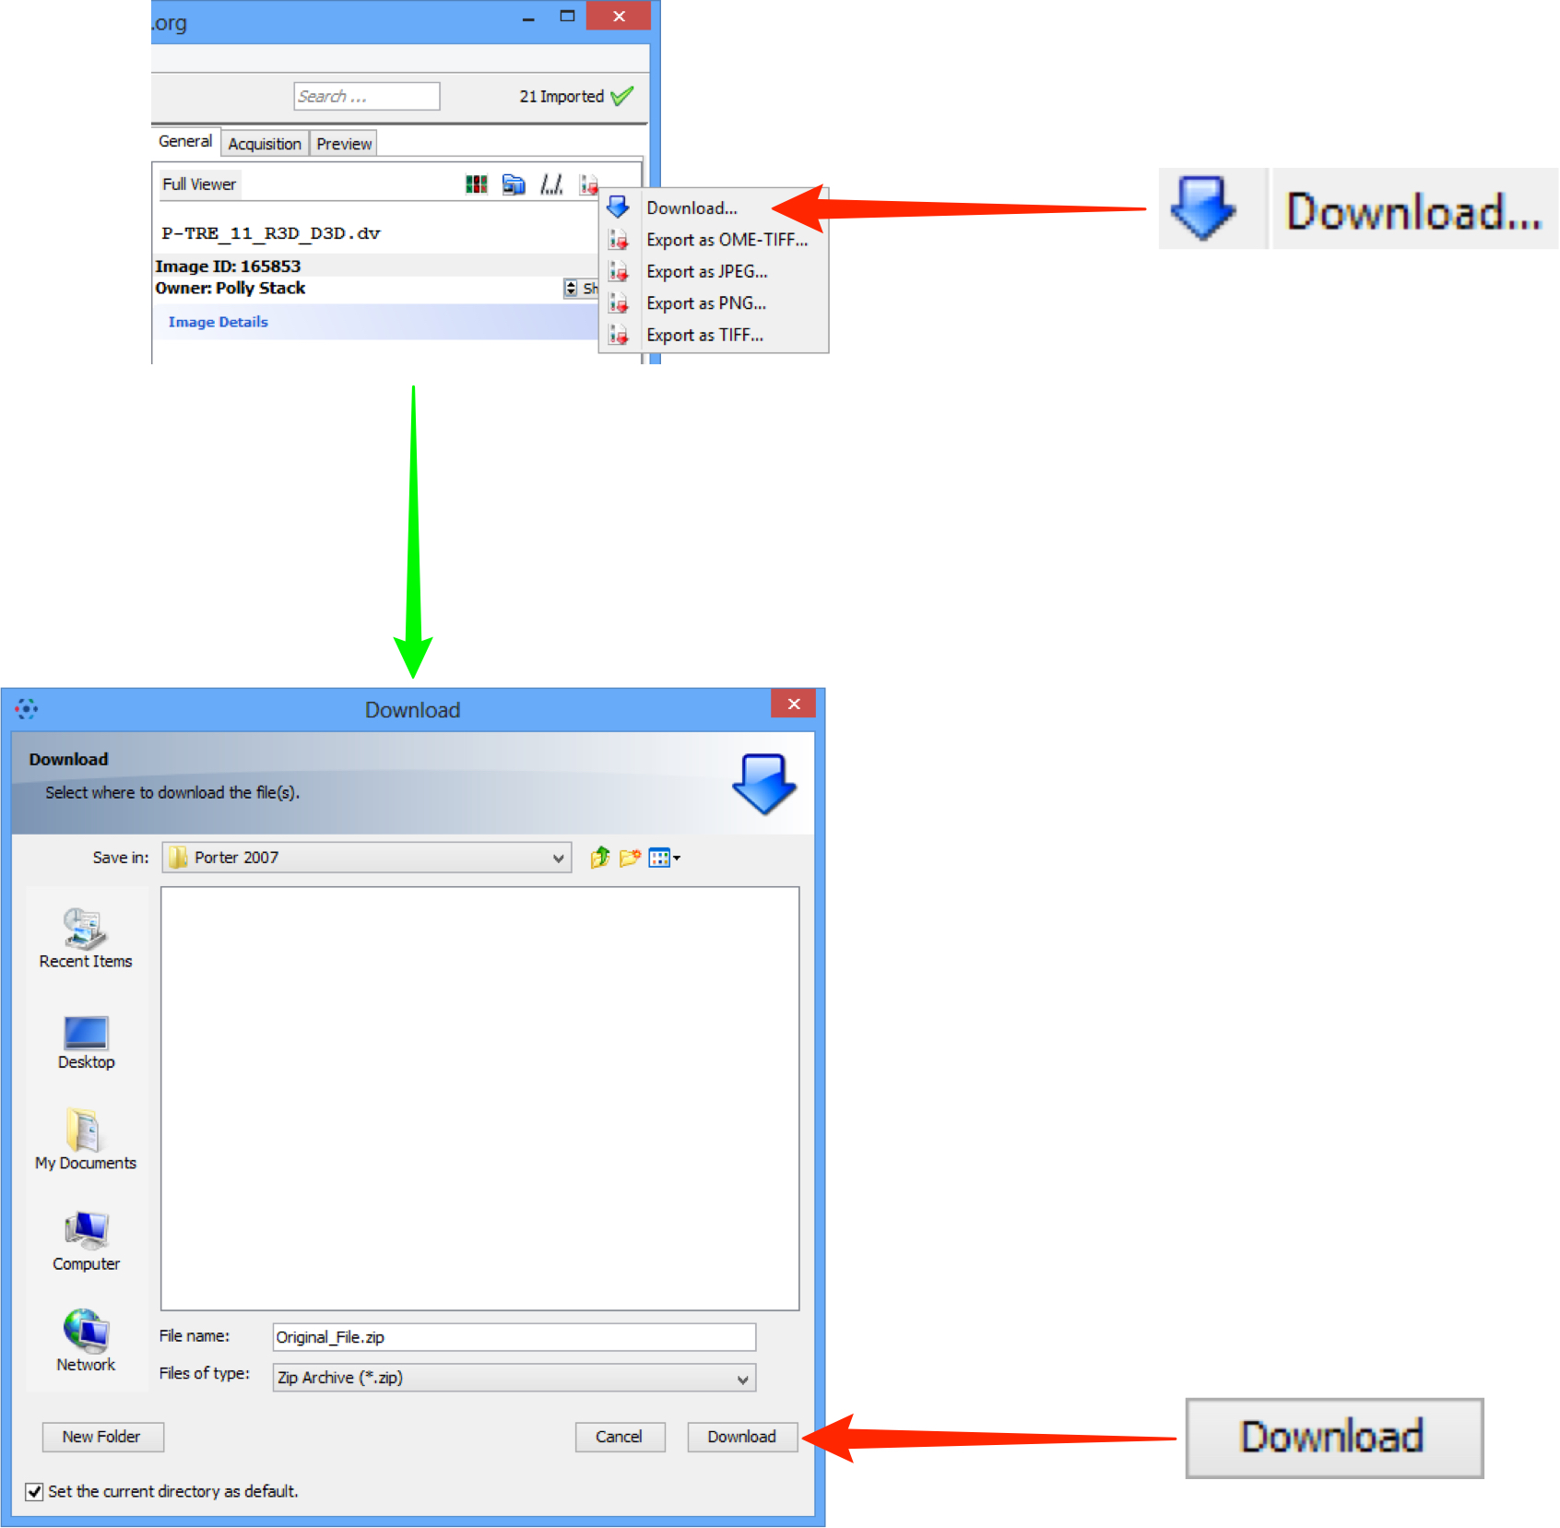

3 Select Export as OME-TIFF from the dropdown menu to export in OME-TIFF format.

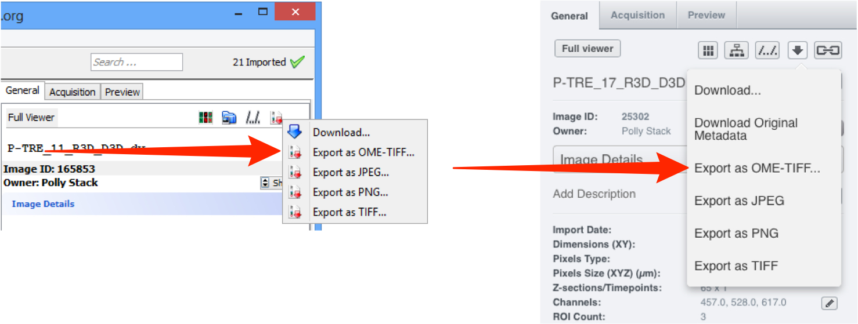

OMERO.insight

Use the file finder in the Export window to choose the destination.
Select the OME-TIFF version to export, from the drop-down in the bottom left.
Click Export to create and download the OME-TIFF as a ZIP archive.

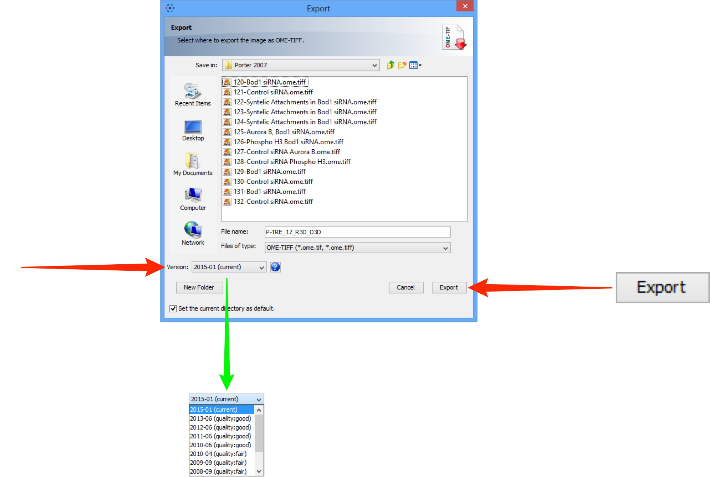

OMERO.web

Click Create to generate the OME-TIFF using the latest version.
The OME-TIFF is attached to the image as a ZIP archive.
Click Download in the Activities window to download the archive.

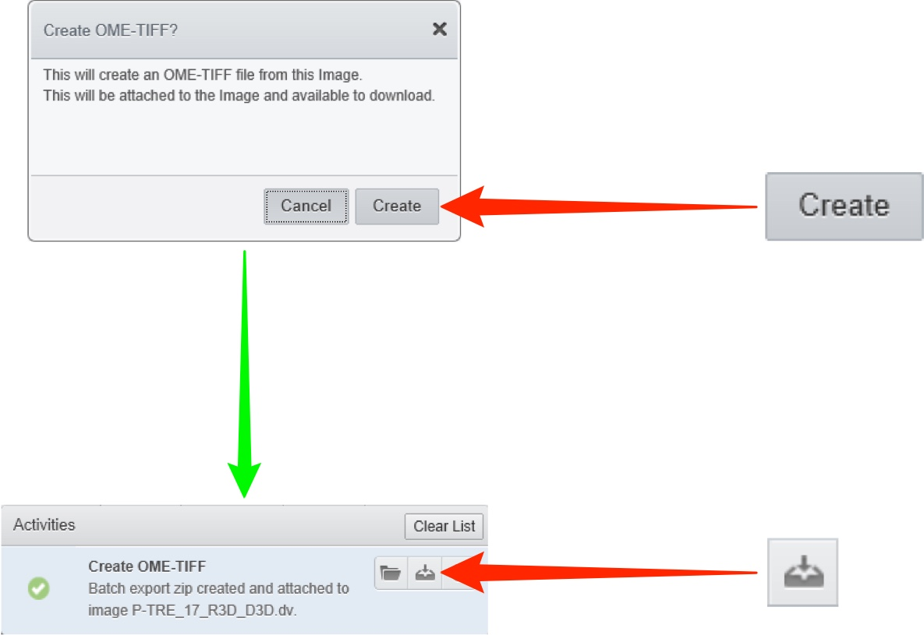

4 Select the appropriate format to export the image as a JPEG, PNG or TIFF.
In OMERO.insight, use File Finder in the Download window to select the destination.
In OMERO.web the file will be downloaded according to your browser convention.

OMERO.insight

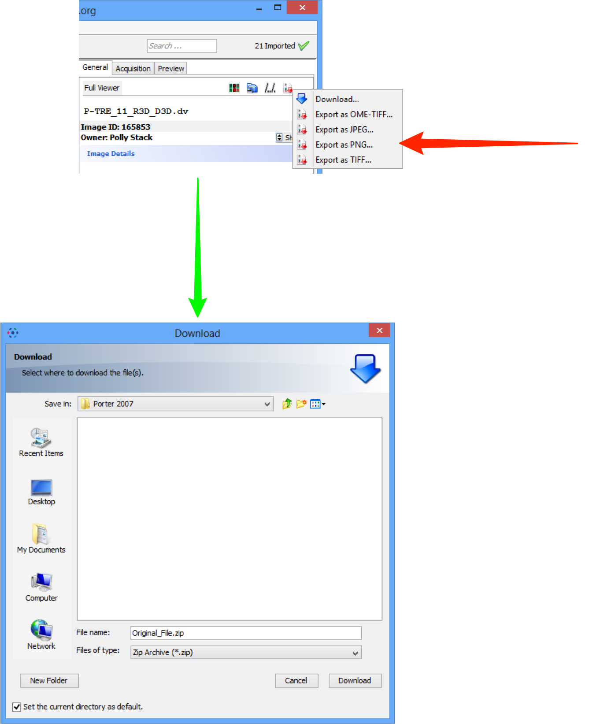

OMERO.web
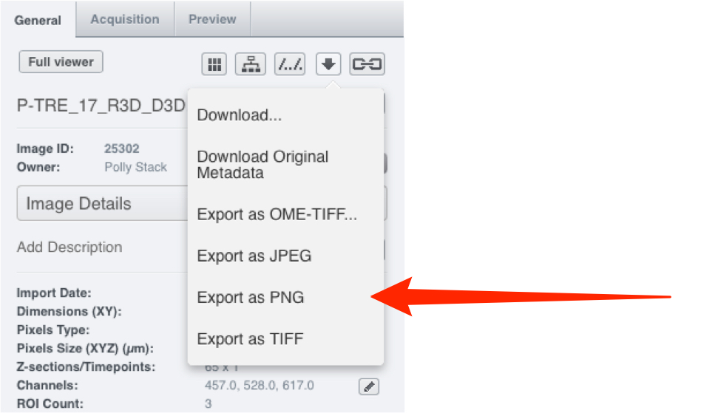

Note: When an image or dataset is downloaded as a JPEG, PNG or TIFF, individual images for each channel and a combined-channel image are generated for the selected Z section or time point for the image(s). All generated images are contained in a ZIP archive.

Using Batch Image Export

1 An alternative way to export multiple selected images or an entire dataset is to use the Batch Image Export script.
This script enables a wide range of parameters to be configured before batch exporting.

OMERO.insight

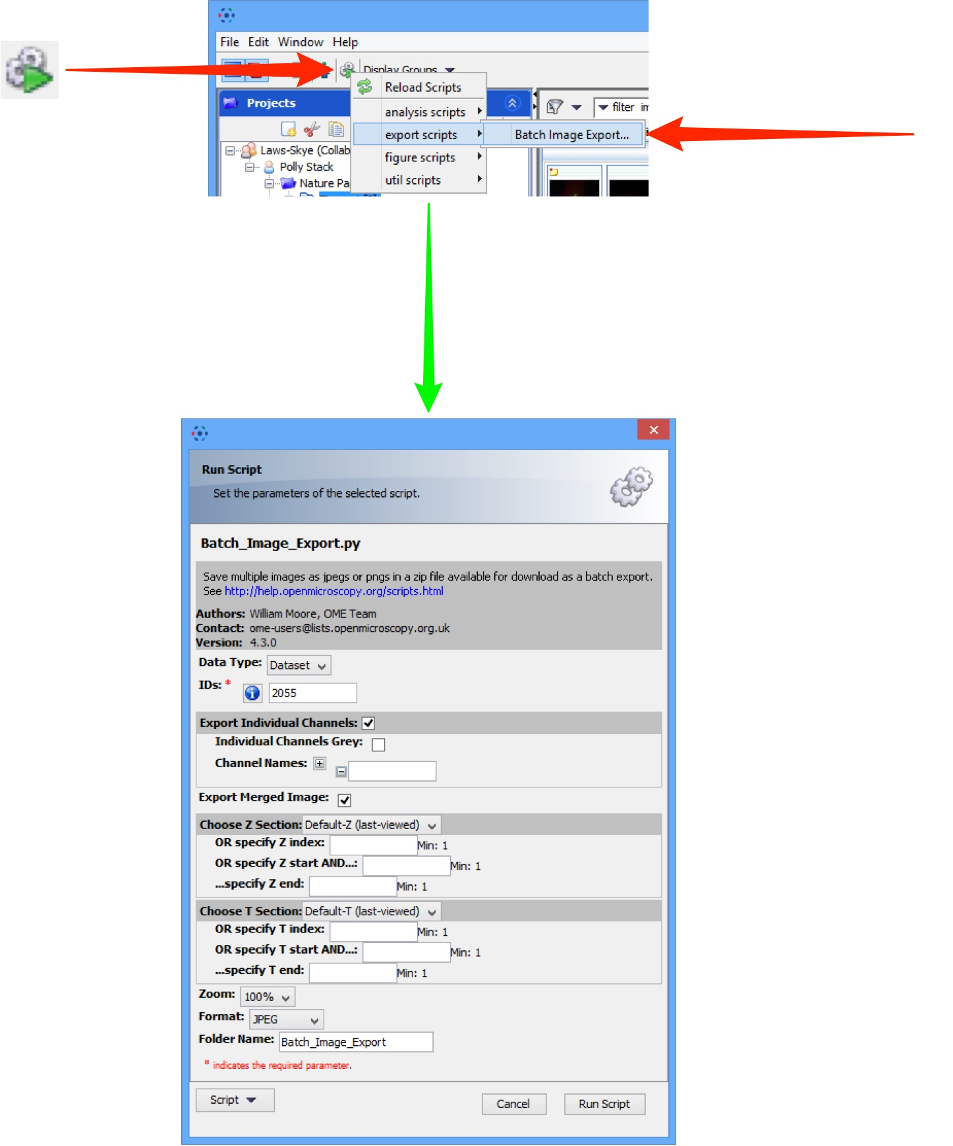

OMERO.web



