7 Use OMERO.web to view your data from any web browser. Your institute will have a unique OMERO.web URL in the form:

servername.institute.ac.uk

OMERO.web uses the same login and has the same functionality as OMERO.insight, except OMERO.web cannot import data
Enter your OMERO username and password and click Login

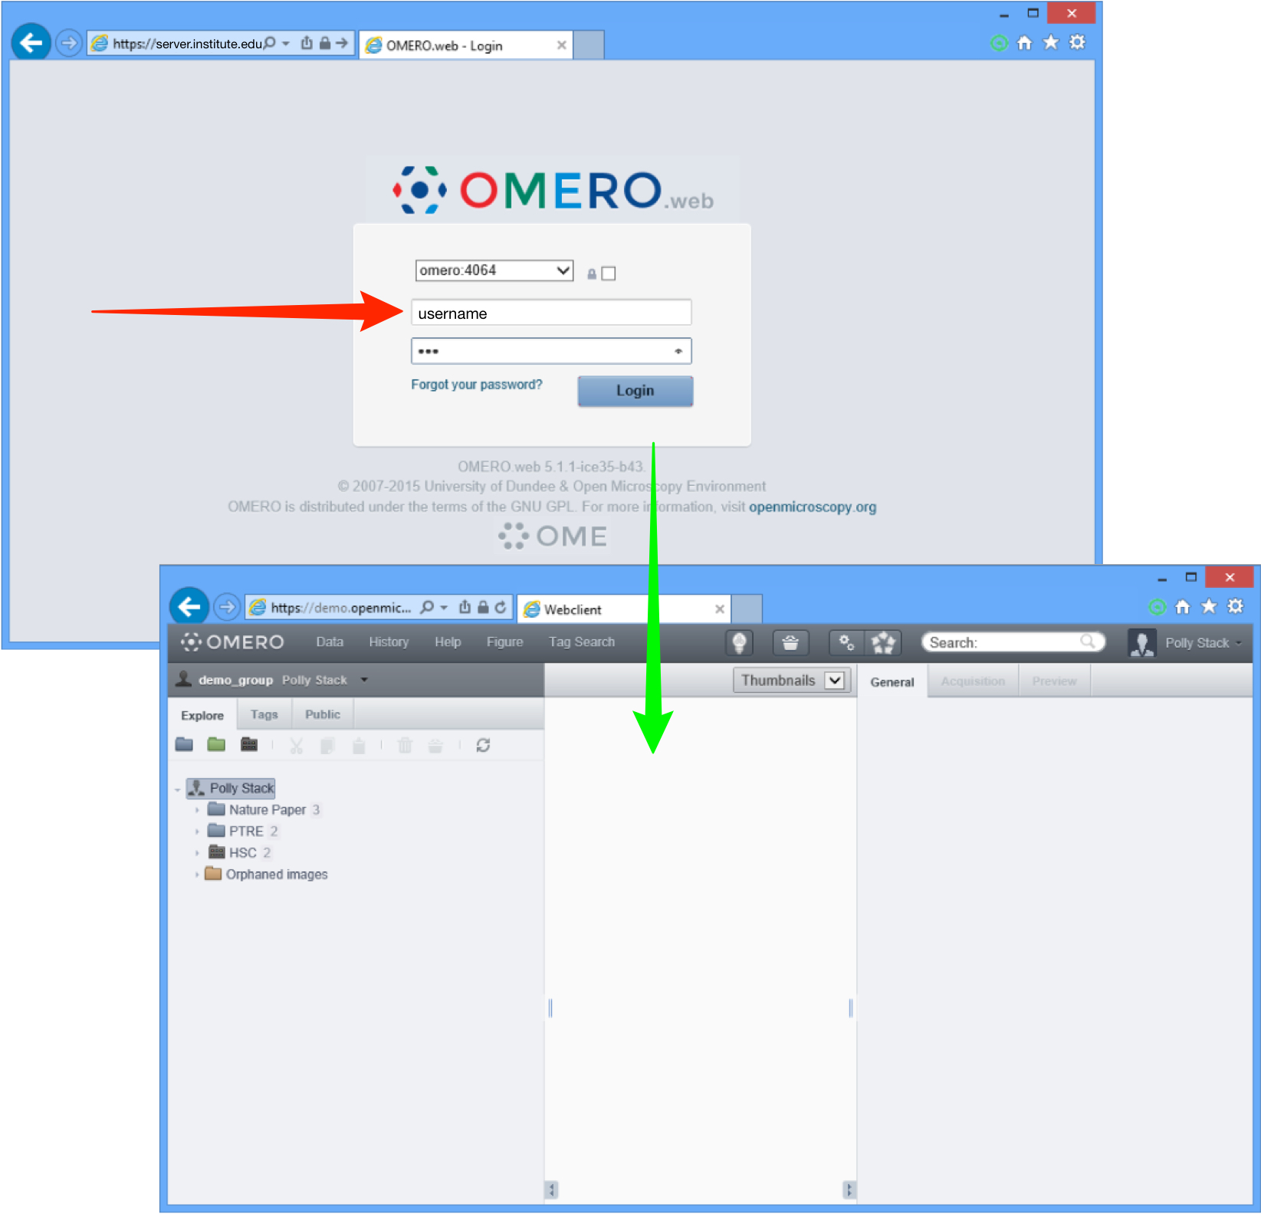

Detailed User Guides for common workflows using OMERO.insight and OMERO.web are available online and to download at:

help.openmicroscopy.org

For other questions or issues please use the forums and mailing lists at:

openmicroscopy.org/site/community
Getting Started with OMERO.insight

Your institute has an OMERO server that allows you to store image data centrally. You can use the OMERO.insight client to upload, view and download data from any computer or laptop on or off-campus.

Your username, password and server address used to log into the OMERO server, are set by your institute, and can be obtained from your OMERO system administrator.

1 Download the OMERO.insight client for your operating system from:

http://downloads.openmicroscopy.org/latest/omero5

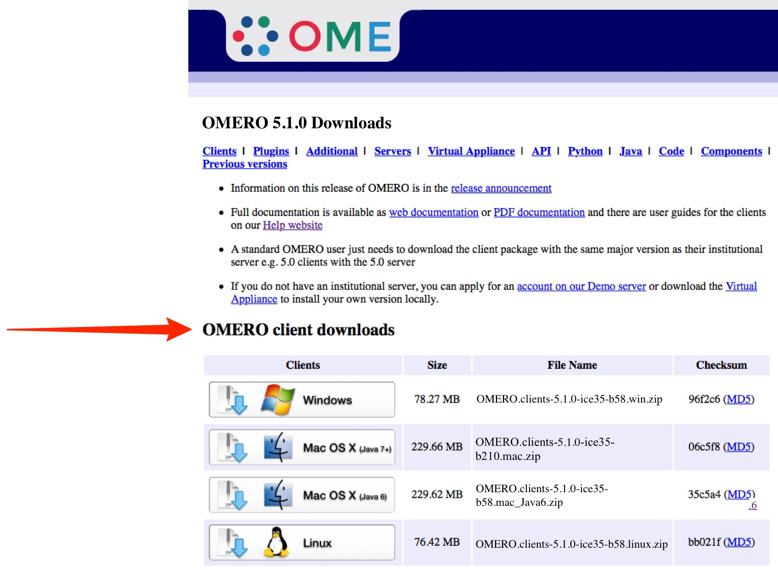

2 Expand the appropriate OMERO.insight client archive

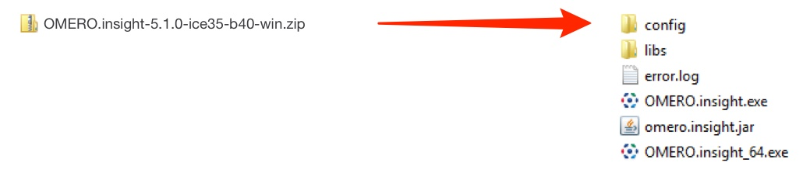
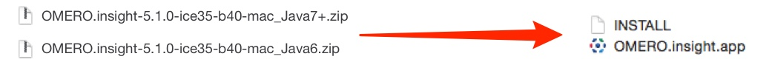
3 Open OMERO.insight client
Click on the Spanner icon.

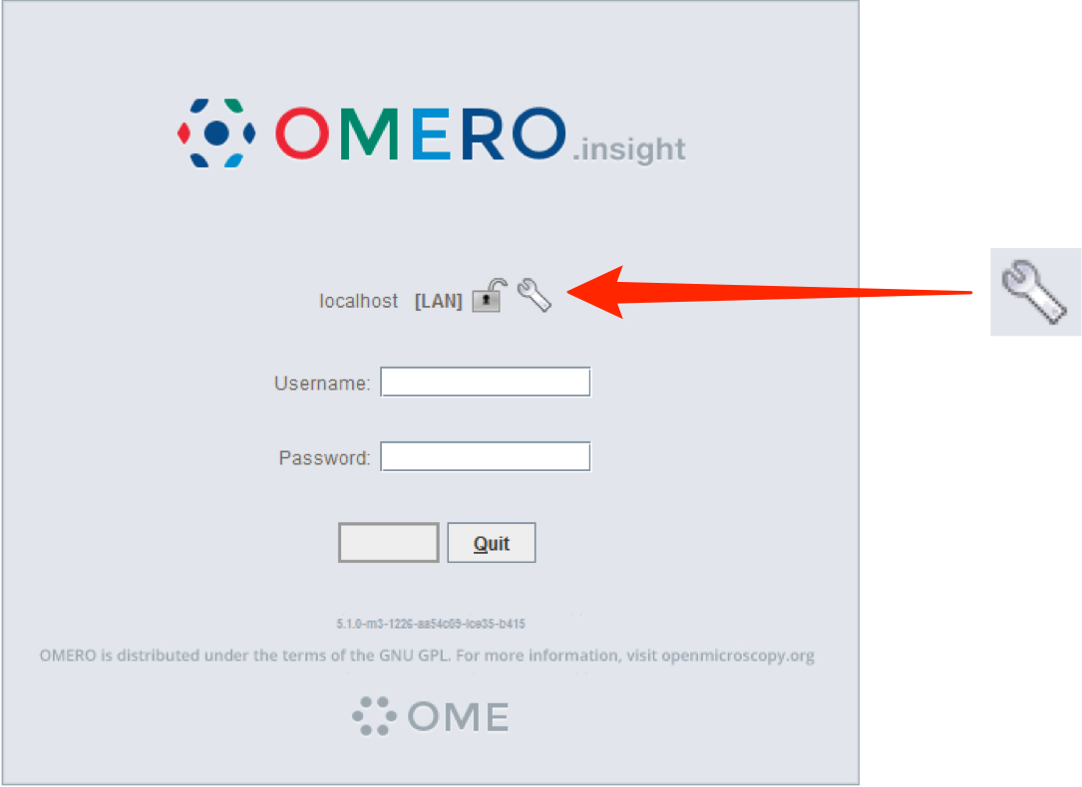

4 In the Add Server dialogue box, click on the + icon.
Enter the server address e.g.:
servername.institute.ac.uk
Click on Apply.

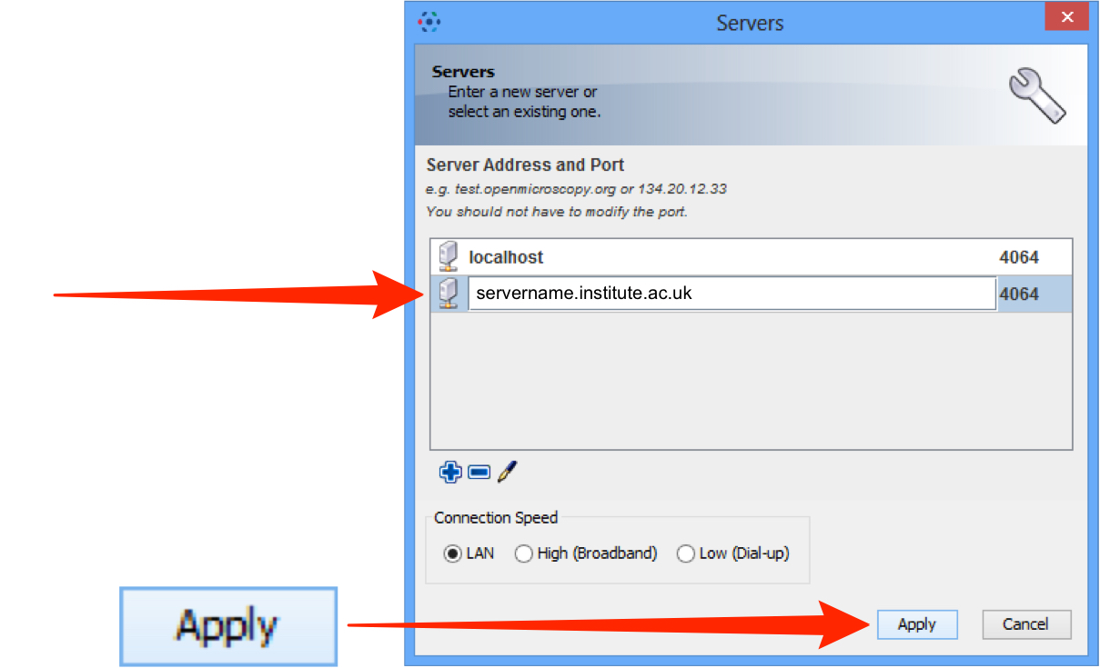
5 Enter your OMERO Username and Password
Click on Login

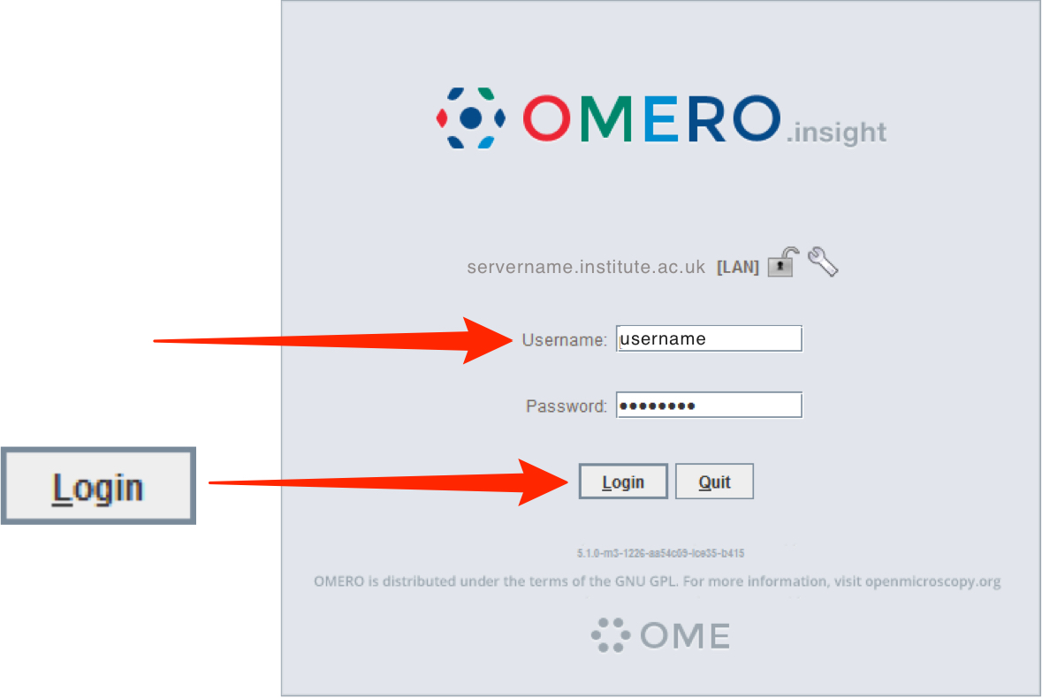

6 Click on the Importer icon to add image data
Using the file chooser in the Importer window select and queue data for import
Use the location window to choose existing or create new Projects, Datasets or Screens to import the data into

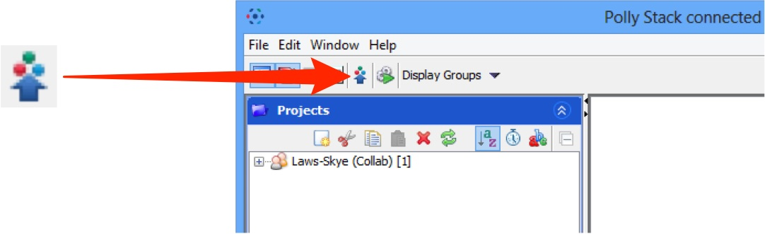

Note: To import data from a networked drive on Macs, the drive must be mounted in the Finder first

